Group Portfolio Phase 2

Peter Colburn - 30017907

Thomas O’Brien - 30021359

Kavell Long - 30004171

Billy Hodges – 30021362

<https://github.com/PeterColburn/Team1>

# Week 1: 10/01/2022

|  |  |
| --- | --- |
| Week 1 |  |
| Activities Set | * Communication and teambuilding power point – Tom * Communication and Teambuilding Research - Peter * Vevox quiz for power point – Kavell * What did we learn and how did we apply to our project - Billy |
| Outcomes of QA activities | Roles and initial discussion on our upcoming power point presentation. |
| Results from QA activities | We created a pipeline to drive us towards our initial goals for the upcoming power point presentation next week. |
| Evidence of activities | See appendix: |

# Week 2: 17/01/2022

|  |  |
| --- | --- |
| Week 2 |  |
| Activities Set | * Communication and Teambuilding Research PowerPoint - Tom * Communication and Teambuilding Research – Peter * Vevox Quiz for PowerPoint – Kavell * What did we learn and how did we apply to our project - Billy   Our seminar was presented, went well with no hiccups with the quiz.  Seminar: Group 2 Team 1 |
| Outcomes of QA activities | Our outcomes provided a PowerPoint seminar that was presented in front of class with a quiz and information on our topic |
| Results from QA activities | Our PowerPoint went as well as expected the only thing said that we could improve on would be where we stood in relation to the projector screen |
| Evidence of activities | See appendix: |

# Week 3: 24/01/2022

|  |  |
| --- | --- |
| Week 3 |  |
| Activities Set | * Peter reflected on feedback from phase 1 * Watched and reflected on the seminars of the week.   Seminar: Group 1 Team 2  Seminar: Group 2 Team 2  Seminar: Group 2 Team 3 |
| Outcomes of QA activities | Focused on reflection on phase 1 and current work and preparation for upcoming activities. |
| Results from QA activities | Due to outside issues Peter was the only group member able to attend the tutorial this week. The reflection on our work has been used to re-route our course of action to better reflect our current work output. |
| Evidence of activities | See appendix: |

# Week 4: 31/01/2022

|  |  |
| --- | --- |
| Week 4 |  |
| Activities Set | * Reflected on previous seminars and gave according to feedback.   Seminar: Group 1 Team 3  Seminar: Group 1 Team 4  Seminar: Group 3 AI Team 1 |
| Outcomes of QA activities | We watched some groups seminars and were able to reflect on things that they have done well and not to help with our own seminars and help them |
| Results from QA activities | We acquired a lot of knowledge from listening to others presentations on their topics and this helped us incorporate some things into our project like the security of our system |
| Evidence of activities | See appendix: |

# Week 5: 07/02/2022

|  |  |
| --- | --- |
| Week 5 |  |
| Activities Set | Started the vulnerability document  SQL injection and Memory Safety – Peter  Insecure Design and vulnerable and outdated components – Tom  Identification and authentication Failures and broken access control – Kavell  Privilege-confusion - Billy  Seminar: Group 1 Team 5  Seminar: Group 1 Team 6 (online)  Seminar: Group 3 AI Team 2 |
| Outcomes of QA activities | We all started a vulnerability document this week that is needed in the success criteria. We split this up based on what topics people wanted to do and attempted to get this done as soon as possible |
| Results from QA activities | From this we found out information about vulnerabilities and decided which ones could be used in the project and we also used skills with google scholar to get work with good references and citations that are displayed in the document |
| Evidence of activities | See appendix: |

# Week 6: 14/02/2022

|  |  |
| --- | --- |
| Week 6 |  |
| Activities Set | Testing – Peter  Data base set – Tom  Vulnerabilities justification and analysis - Kavell |
| Outcomes of QA activities | During this week we were cleaning up the last few things that we needed to do for the success criteria which were a bit of extra code like with the database and finishing up with the vulnerabilities and getting the last testing done before the end of the phase |
| Results from QA activities | The results from this showed that our program was currently up to scratch and the testing went very well. We also found that the vulnerabilities were complete, and that the database development was well on the way for our project to be completed in the last term. We also investigated implementing the 2-vulnerability protection into our design that would be used during phase 3 |
| Evidence of activities | See appendix: |

# Appendix

## Week 1: Evidence

* Power Point:

* Quiz:

* Research: - see Communication_and_Teamwork_Research on Github for more

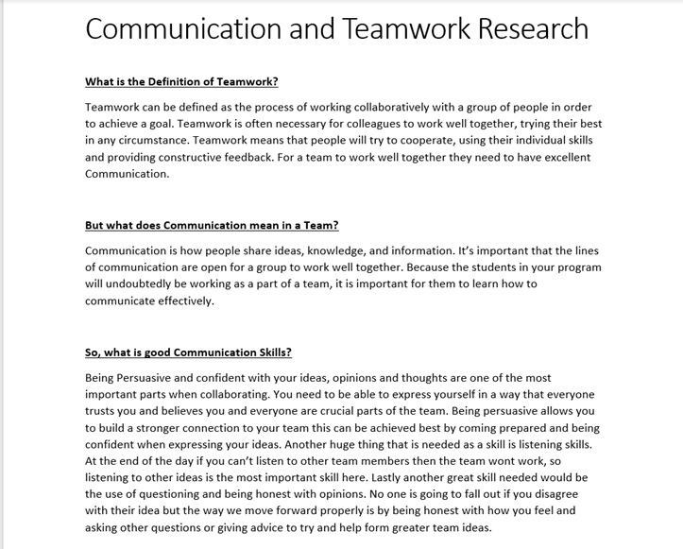

## Week 2 Evidence

N/A (Same as week 1)

## Week 3 Evidence

N/A

## Week 4 Evidence

N/A

## Week 5 Evidence – see VulnerabilityDoc on GitHub for more

## Week 6 Evidence – see Testing on GitHub for more

